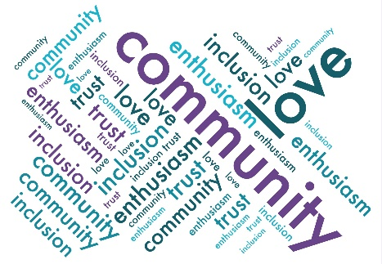
Friends of Droxford Church
Agenda for the Events sub-group meeting
13 Feb 2024 @ 5 pm in the Community Room

- Apologises for Absence.

- Approval of Minutes 30 Jan 2024.

- AGM and Celebration – Expected numbers, reports published, who’s doing what when.

- DD 80th Anniversary – Confirm programme.
- Confirm whether Wilfrid’s are on board for the tea dance.
- Agree ticket prices and budget.
- Discuss publicity by whom and which routes.
- Discuss plan B and contingencies.
- Country Fair offering and FODC offerings.
- Country Fair School art show

- Events Team Update.

- New Events or Fund-raising opportunities and plan for 2024 including Roger Coleman and Ceroc Dance event.

- AOB.

- Date of next meeting.

