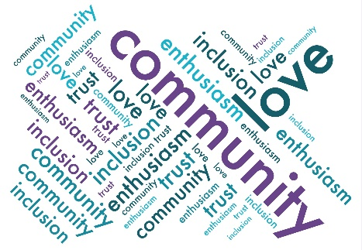
Friends of Droxford Church
Agenda for the Events sub-group meeting
30 Jan 2024 @ 5 pm in the Community Room

- Apologises for Absence.

- Approval of Minutes 28 Dec 2023.

- AGM and Celebration – Expected numbers, reports and notices, volunteers and refreshments. A/V needs.

- DD 80th Anniversary – Final schedule for the talks, film, map room visit and tea dance and anything else.
- Discuss publicity by whom and which routes.
- Tea dance singer, instructor, gauging numbers for interest, booking the village hall and refreshments.
- Country Fair steam rides, station backdrop and ticket sales.
- Country Fair Heritage offering including the heritage recordings.
- Country Fair School art show?

- Events Team Update.

- New Events or Fund-raising opportunities and plan for 2024 including Roger Coleman and Ceroc Dance event.

- AOB.

- Date of next meeting.

