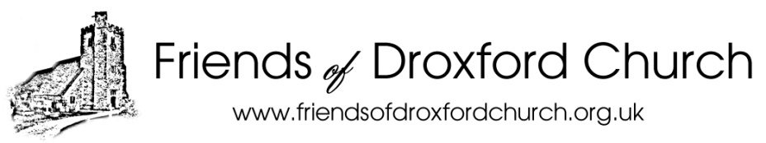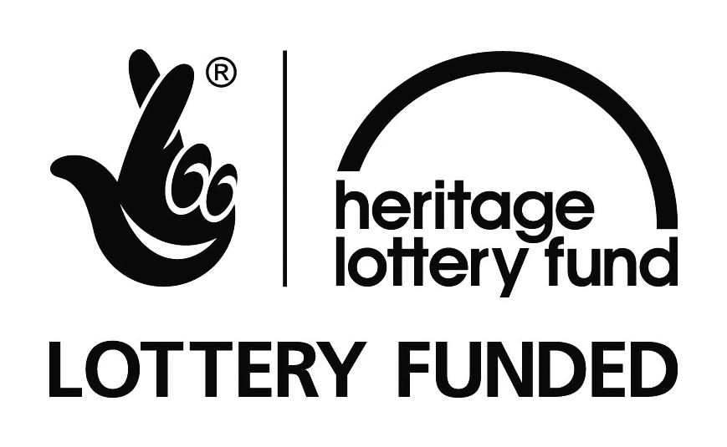
Droxford Parochial Church Council
Embargoed until 00.01 hrs on Monday 7th March 2016

Droxford Church Community Hub and Heritage Project secures Heritage Lottery Fund investment
The Friends of Droxford Church (FODC) and Droxford Parochial Church Council (PCC) are pleased to announce that their application to the Heritage Lottery Fund (Grants for Places of Worship programme) has been successful. A confirmed grant of up to £188,300 has been awarded, bringing the total contribution to the Community Hub Project from the Heritage Lottery Fund to £222,200.
What does this grant mean for Droxford?
Droxford PCC can now plan to start work in Droxford Church on the first phase of the Community Hub and Heritage Project:
- To carry out the urgent restoration work to the church tower, roof and drainage system
- To install glazed screens in the north chapel in order to create a Community Room
- To deliver a programme of activity to engage people with the heritage of the church

Contractors have been appointed for the major works which are expected to start in early April, and to last approximately 5 months.

Concurrently we are seeking further grant aid and private donations to enable work to start on an extension for toilet, kitchen and office facilities, which are needed to support a Community Café and other secular activities in the church building.

Quotes
Commenting on the award, Revd Tony Forrest, Rector of the Meon Bridge Parishes, said:
“We’re delighted that the Heritage Lottery Fund has given us this support. The award will enable us to start work in April to restore this lovely Norman Church, but equally important it will enable us create a Community Room which can become the focus for social activities as well as heritage exploration. It will support sustainable community development, and enable us to serve our communities better, especially the isolated, the young and the elderly, in Droxford and the Meon Valley.”

Stuart McLeod, Head of HLF South East, said:

“Droxford Church is a local landmark in a beautiful location that has played an important role in this area for centuries. This money, raised by National Lottery players, will help preserve the Church for the future and open up more of its fascinating history to explore.”

Notes to editors
About the Droxford PCC and Friends of Droxford Church
Droxford Parochial Church Council (Chairman, Reverend Tony Forrest) is responsible for running and maintaining St Mary and All Saints Church, in Droxford. The Friends of Droxford Church (FODC) was set up as an independent organisation in 2011 to restore and enhance the Church building for wider Community use. More information about our organisation and this Project is available on our website www.friendsofdroxfordchurch.org.uk.
About the Church
St Mary and All Saints Church is one of few Grade I listed buildings in the Meon Valley and the only one in Droxford. It has been the centre of worship for the village community for nearly 900 years. The Church is in the Anglican Diocese of Portsmouth, and stands in the centre of the village just 100 yards from the village square. The earliest and main parts of the church date from the middle of the 12th century, the first records dating from 1150 to 1160. The Church was added to Historic England’s ‘At risk’ register in 2014. The aim of this project is to restore the church fabric, and also to enable the building to be used for secular activities by a wider range of people.
About the Heritage Lottery Fund
Thanks to National Lottery players, we invest money to help people across the UK explore, enjoy and protect the heritage they care about - from the archaeology under our feet to the historic parks and buildings we love, from precious memories and collections to rare wildlife: Find out more at www.hlf.org.uk.
Further information
For further information, images and interviews please contact John Symes at (Chairman, Friends of Droxford Church) on Tel: 01489877643 or Email: jmdsymes@btinternet.com.
Visit our websites at www.friendsofdroxfordchurch.org.uk and www.bridgechurches.org.uk

