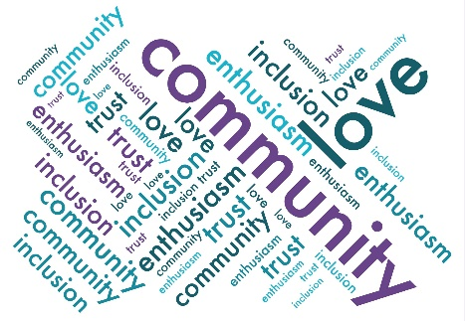
Friends of Droxford Church
Minutes of the Events sub-group meeting
5 March 2024 @ 10 am in Clare’s kitchen

Present: Sally Sturt, Tony Hoile, and Clare Hooper.
- Apologises John Symes and June Kershaw.

- Minutes from the last meeting approved.

- AGM – The attendees coming in the west door worked well and kept the church warmer. As a consequence, move the drinks table to the narthex. Circulate canapes around guests instead of encouraging into the community room. The timing (6.30) start meant many wanted to rush off for their evening meal. Consider a different start time and/or serving a glass and canapes on arrival. Finally, all speakers need microphone training as some weren’t audible.

- DD 80th Anniversary –

Update between meetings as follows:

“Clare and SS met because they were really concerned about marketing and getting on with the publicity plus the Bridge copy deadline was also 6 March. They agreed on wording for the main programme and developed wording and posters for each of the events. JK had got a template for the main poster and it was hoped at the meeting (if not before) to insert the agreed wording into the template developed.

SS got agreement from Margaret to sell tickets through Wilfrid's. SS to work on setting up the online ticket sales via jumblebee.

Margaret and Wilfrid's have declined to provide the teas and cakes at the tea dance. FODC can do it ourselves. SS to recruit some more volunteers to bake and serve teas.

It would appear that there is little appetite around the village for a dressing up competition at the country fair. Accordingly, given everything else, this aspect won't be continued. Budget revised in line with the experience from the AGM.”

At the meeting it was agreed, there would be no children’s art show in the church. The steam engine is a definite and in our publicity. Clare volunteered JH and their van. TH to recruit support he needs with Clare, Rosie H (both before 2pm) and Bonike and Sally to sell tickets each for an hour during the fair. It was suggested that the steam track could go along the manor house drive as an alternative. TH to discuss logistics with James.

SS to finalise posters with JK. SS to do actual tickets and place in Wilfrid’s. Clare to liaise with Ian of the Bridge to get the posters in the next edition. Budget and volunteer numbers reviewed and agreed.

The marketing strategy was refined as follows:
SS – Droxford and environ villages.
Naval and military.
Operation overlord.
WI
JK- Local schools and collages especially those studying history or dance.
Dance groups and clubs.
Clare- Local U3A.
History groups.
Dance groups and clubs.
Southwick revival.
Nick Lambert.
TH - Train enthusiast clubs or groups
Meon Valley Railway Group
NADFAS or Art Society
Each person to research those areas and where possible use the appropriate poster electronically or displaying physically looking for mutual marketing opportunities.

Clare to send a copy of the tea dance poster to Amy for approval and for her to promote.

- Events Team Update – Not discussed.

- New Events – Not discussed aside from moving the Shantyheads concert from July to November due to organisers fatigue.

- AOB – None

- Date of next meeting – tba.

Events Timetable Responsible Trustee Date if known

Tea Dance lessons Clare April/May 2024
Talk on Droxford Station and Railway by Tony Williams John 9 May 2024
Churchill film Clare/Tim 15 May 2024
Talk on Churchill in this area by Ben Stoneham John 23 May 2024
Steam Engine at the Country Fair Tony 1 June 2024
Previous film/video heritage recordings in the Narthex John 1 June 2024
Tea Dance Clare 2 June 2024
Art Exhibition June September 2024
Safari Supper Sally October 2024
Xmas Fair November 2024
Shantyheads led by the PCC Jeff/Clare November 2024

