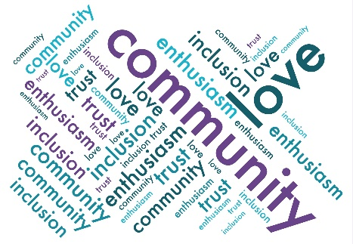
Friends of Droxford Church
Minutes of the Events sub-group meeting
26 October 2023 in the Community Room and then Narthex

Present: Sally Sturt, Tony Hoile, John Symes and Clare Hooper.
- None

- Approved

- Jesus My Boy - JS commented that the existing sound system was adequate. TH offered to do some experiments to identify optimum settings and advise James. JK didn’t find the lighting conducive and whilst awaiting the improvements, maybe we should consider portable lighting. Clare wanted more discrete promotion of FODC. SS agreed and had already considered that a printed message left on each pew might work better. SS had written a Bridge article which JS had approved. SS to send to Clare and Mick for approval. Clare to do a formal thank you to Mick advising that over £700 had been raised. SS had updated the “Running Events Points of Note”.

- DD 80th Anniversary – James, the new Chairman of the Country Fair, joined us. He explained that they have been exploring informally what theme for June 2024 but were merely at the discussion stage. He was very amenable to communicating and coordinating to do something special next year to mark the Anniversary. Ideas ranged from doing a themed evacuated kids event with the school, the best dressed attendee with a theme of 1940s etc. James proposed less history and more action or involvement. He also proposed having a series of timed events during the country fair. Definitely involve the café and school. FODC would hopefully have the steam engine, but the station used for the 70th anniversary may not survive coming out of retirement. Instead, a recreated station was proposed by TH. JK would give the DVD of the 70th anniversary country fair for James to review.
JS has confirmed in principal with the speakers to hold 2 talks in the month leading up to the country fair. JS to progress Clare proposed discussing with the village hall to show a 1940s uplifting film end of May preferably about the DD. Clare to progress. Clare had already registered with the DD museum but they have yet to formalise their plans. If there was to be a tea dance, then SS proposed Amy Baker to sing and provide the music. SS to explore. JK mooted that the art exhibition planned for the country fair may not fit with the planned anniversary and so confirm when planning for the DD celebrations.

- Xmas Fair 18 November – FODC had been approached by the village hall and have taken a table at the xmas fair which is spilling over from the village hall to include the narthex. Clare to ask Jeff for some poinsettias to sell on behalf of FODC. JK to organise and run the FODC table.

- AGM – JK to use to launch the revised website. JK to prepare a Bridge article for submission early January to promote the AGM and highlight the revised website. SS proposed that the AGM would include refreshments to thank any volunteer associated with the Church. SS to organise.

- AOB – SS to rename the WhatsApp group for future events.

- Date of next meeting Thursday 28 December at 5pm to plan and firm up on DD events.
Events Team:
Jo Willoughby Claire Francis
Julia Keitley Gill Parratt
Nicky Higgens Elizabeth Fowler
Rosie Hoile (TC event and pew cushion exhibition) Clare Hooper (TC event and play)
Kate Reynolds (TC event) Lynne Dumbrell (TC event)
Jill Lean (TC event) Louise Hudson (TC event)
Nick Capon (TC event) Tim Dumbrell (TC event)
Sandy Ballie-Strong (TC event)
To Ask:
Tina Rugs Gail Jones

Events Timetable Responsible Trustee Date if known

FODC AGM and social Sally/June 19 Feb 2024
Talk on Droxford Station and Railway by Tony Williams John May 2024
Talk on Churchill in this area by Ben Stoneham John May 2024
80th D-Day Remembrance Clare 1 June 2024
Art Exhibition??? June 1 June 2024

Events to be investigated:

Author talks eg Rev. Cole, Robert Goddard Angela Findlay, Kate Mosse Sally
Dale – Droxford Annual Literary Event Sally
Tribute band June
Singing (carols) concert by Portsmouth Grammar Tony
Talk by Matt le Tissier Jeff
Talk on walking the South Downs by Heather Lacey Sally
Football personality converted to Christianity June
Concert by Amy Baker Sally
Talk on sailing the Atlantic by Geoff Holt Sally
Talk by Ben Ainsley Sally
Talk on Meon River and water voles by Elaina Whittaker Sally
Exhibition of Landscape photography through SDNP comp. Sally January 2025

